|  |
| --- |
| EPAM Systems, RD Dep., RD Dep. |
| MTN.BI.03 SQL for Analysis  **Introduction to OLAP** |

|  |  |  |  |  |  |
| --- | --- | --- | --- | --- | --- |
| REVISION HISTORY | | | | | |
| Ver. | Description of Change | Author | Date | Approved | |
| Name | Effective Date |
| 1.0 | Initial Version | Mikita Kandratsiuk | 14-Nov-2017 |  |  |
| 2.0 | Report | Aksana Kuratnik | 15-Nov-2017 |  |  |

Contents

1. Frameworks 3

2. Presentation 3

3. SQL for analysis 3

3.1. Topic 2. Task 2 (please, make an example of usage GROUPING_ID). 3

3.2. Topic 3. Task 2. 4

# Frameworks

Please, develop your assigned frameworks.

# Presentation

Presentations about methodologies.

|  |  |  |
| --- | --- | --- |
| Aksana Kuratnik |  | Kanban |
| Aliaksandr Labayeu |  |  |
| Vitaliya Adamchuk |  |  |
|  |  |  |
| Saida Melikava |  | Scrum |
| Valeryia Lupanava |  |  |
|  |  |  |
| Alina Makarets |  | Agile |
| Arina Marchenko |  |  |
| Hanna Takushevich |  |  |
|  |  |  |
| Mikita Tur |  | Other |
| Olga Hilko |  |  |
|  |  |  |
| Gleb Kulvanovski |  | Waterfall |
| Anastasiya Khilko |  |  |
| Hanna Hul |  |  |

# SQL for analysis

## Topic 2. Task 2 (please, make an example of usage GROUPING_ID).

Task 2

Analyze max, min and summary sales in the report below by:

* December 2000;
* Two channels: Internet and Direct Sales;
* All States.

Build the query using Oracle SQL for Aggregation and design the same report (export results to Excel).

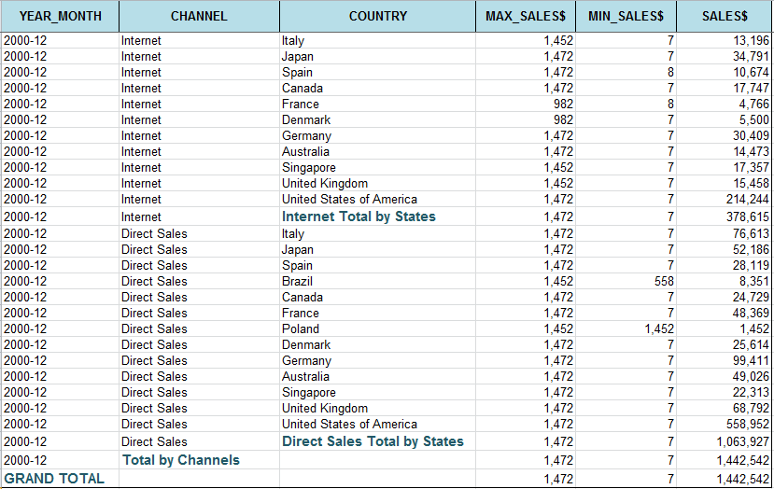

**Tasks Results**

Please do tasks above. You must prepare the report with all SQL-scripts and results screenshots.

P.S.Programming code is in the SQL file in attachment.

Sales Report:

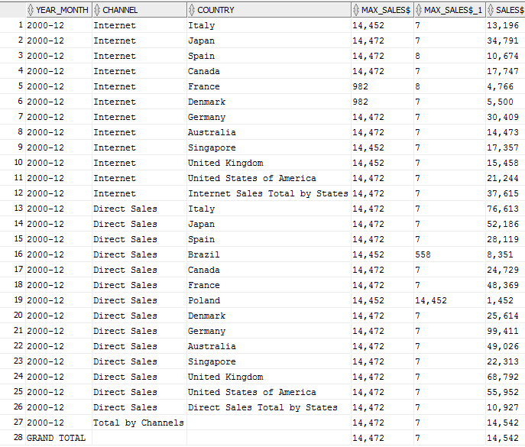

Export to Excel:

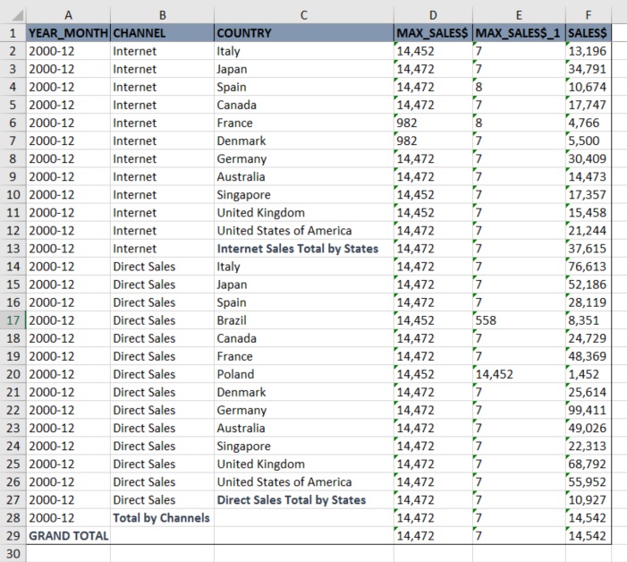

## Topic 3. Task 2.

Task 2

Напишите запрос для формирования отчёта о продажах в Азии всех продуктов из категории Photo за 2000 год по кварталам. Вычислите итоговые суммы (TOTAL и YEAR_SUM).

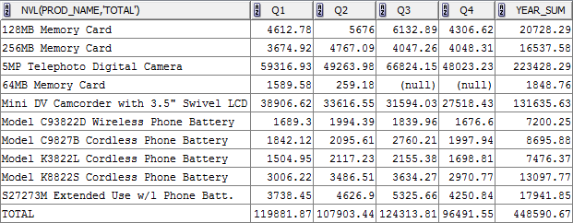

**Tasks Results**

P.S.Programming code is in the SQL file in attachment.

Sales Report:

